**Add your Exchange account to your iPhone**

Tap Settings > Mail > Add Account > Microsoft Exchange.  
If you're adding another account, tap Accounts > Add Account.

Enter your address

Enter your email address, then tap Next. You can also enter an account description.

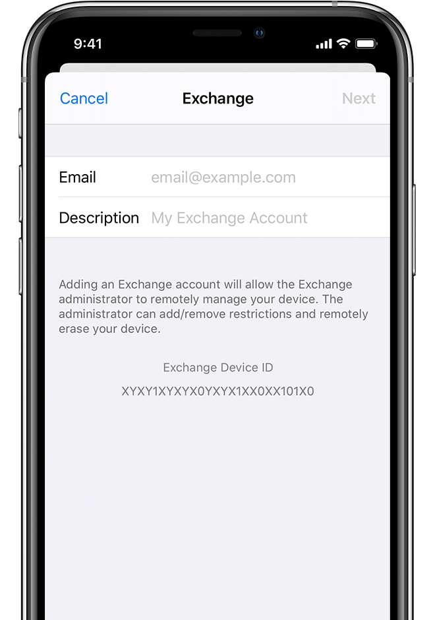

Connect to your Exchange Server

After you enter your email address, choose Sign in or **Configure Manually**.

Tap Configure Manually to set up your account with Basic authentication. Enter your email password, then tap Next. You might also be prompted to enter additional server information, which you can get from your Exchange Server administrator.

**Server:mail2.perfume-center.com**

**Domain: perfumecenter**

**Username: perfumecenter\username**

**Password: As IT provided**

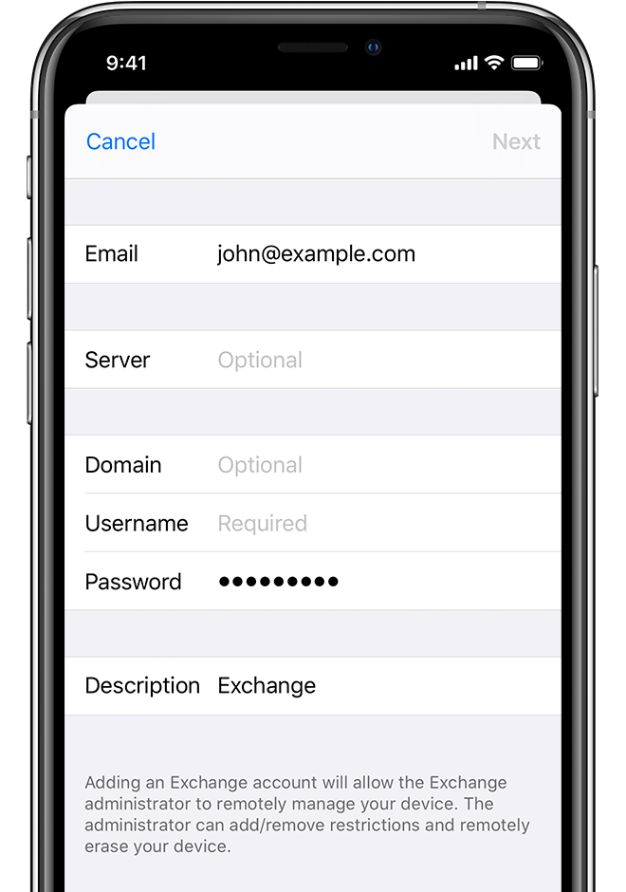

**Sync your content**

You can sync Mail, Contacts, Calendars, Reminders, and Notes. When you're finished, tap Save.

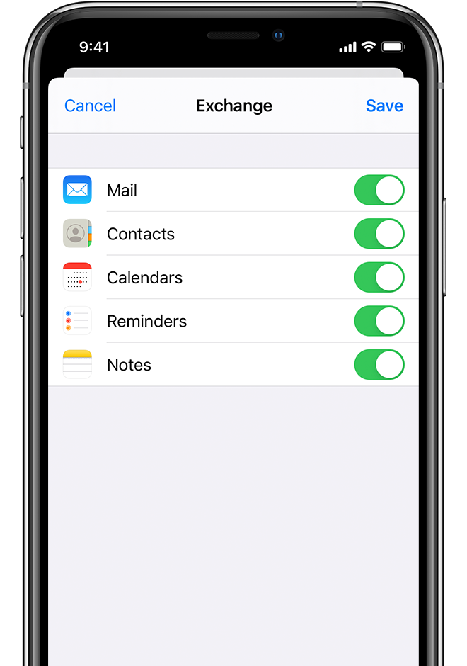

Please check your mail app in your iPhone. You will able to see the mails

**For Android phone**

**Touch Settings.  
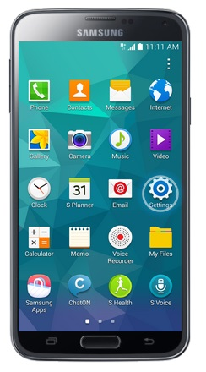**

1. **Scroll to and touch Accounts.  
   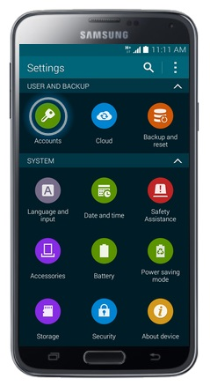**
2. **Touch Add Account.  
   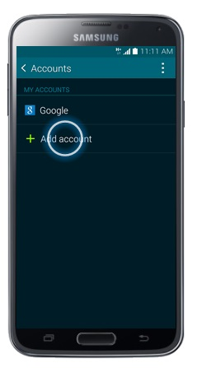**
3. **Touch Microsoft Exchange ActiveSync.  
   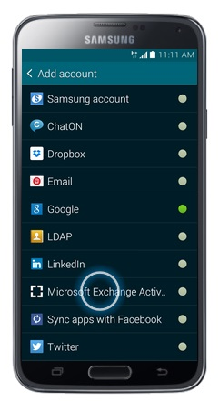**
4. **Enter your workplace email address.  
   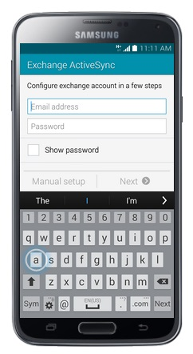**
5. **Touch Password.  
   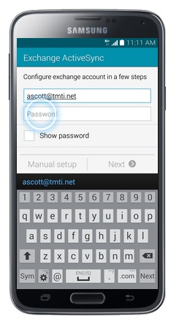**
6. **Enter your email account Password.  
   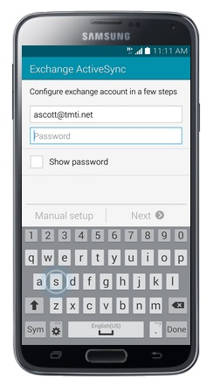**
7. **Touch Next.  
   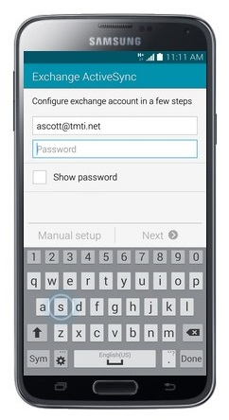**
8. **Touch Domain\username :perfumecenter\username  
   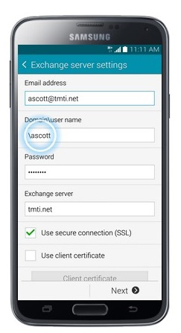**
9. **Scroll to and touch Exchange Server.  
   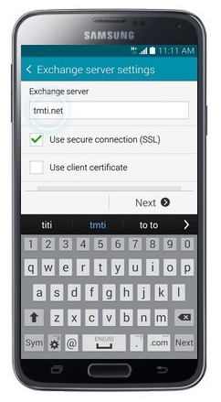**
10. **Enter the Server address. (*The Server is: (mail2.perfume-center.com*)  
    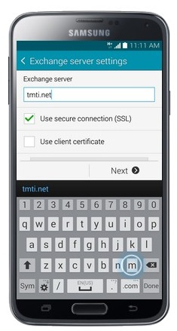**
11. **Touch Next.  
    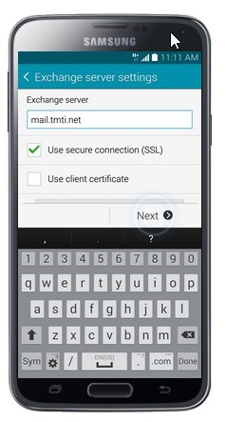**
12. **Touch OK.  
    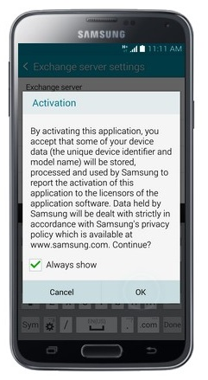**
13. **Wait while the phone verifies the account.  
    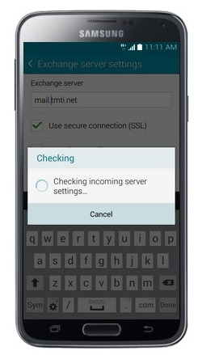**
14. **Touch OK.  
    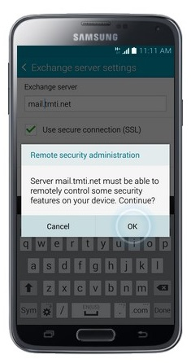**
15. **Scroll down and touch Next.*Some options will be pre-selected. You can change any of the displayed options before proceeding.*  
    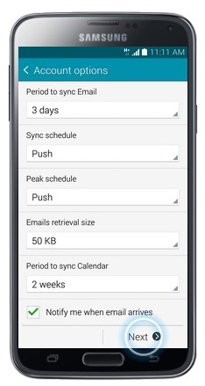**
16. **Touch Activate.  
    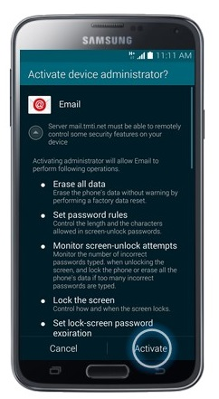**
17. **Edit the Account Name as you wish.  
    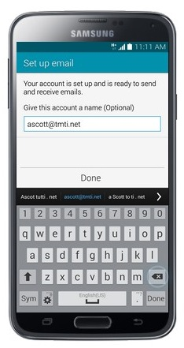**
18. **Touch Done.  
    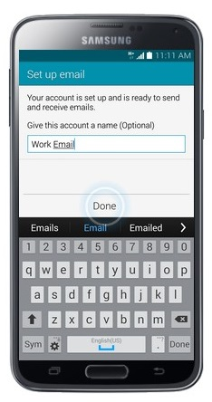**
19. **The email account has been added. *To view the email account, press the Home button.*  
    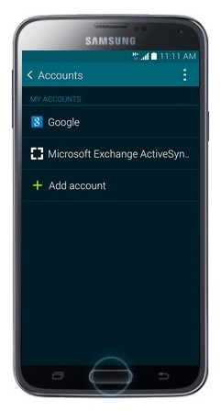**
20. **Touch Apps.  
    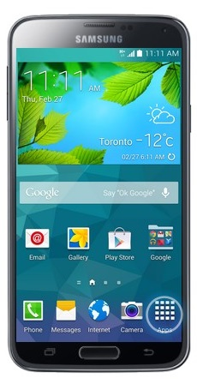**
21. **Touch Email. *Your email will sync to your phone once you touch the Email button.*  
    